Assignment – 04:
Create a public bucket in AWS. Upload a file and give necessary to check whether the file URL is working.

Steps:
- Search for s3 and click on Buckets feature under S3 service.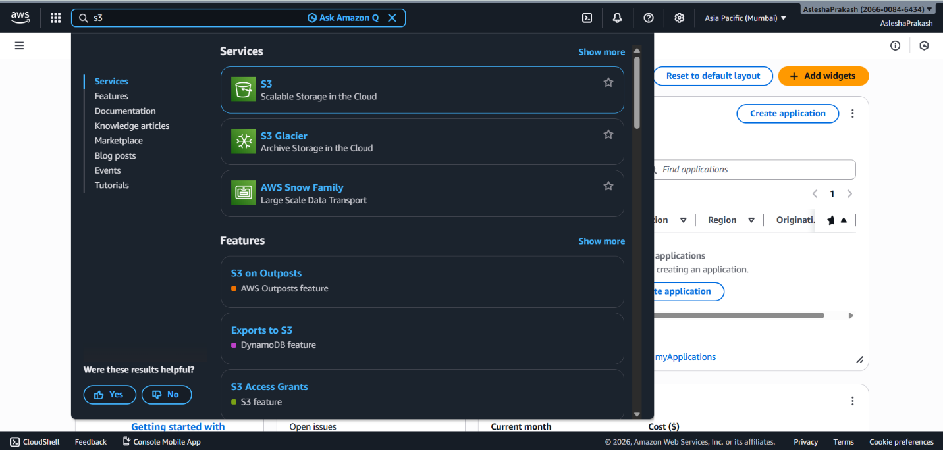

- Click the Create bucket button appearing on top right of General purpose bucket section.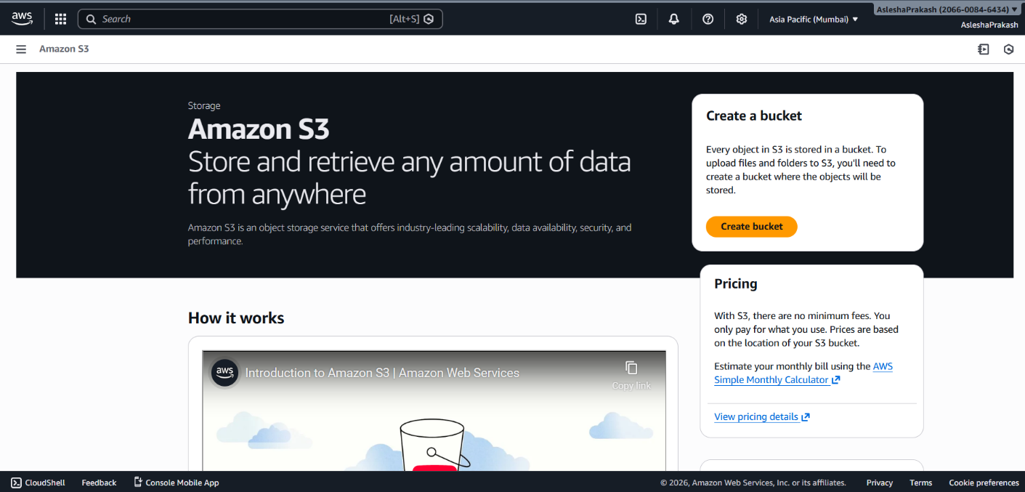

- Add a bucket name. Make sure the region is as per the final choice since it cannot be changed once created.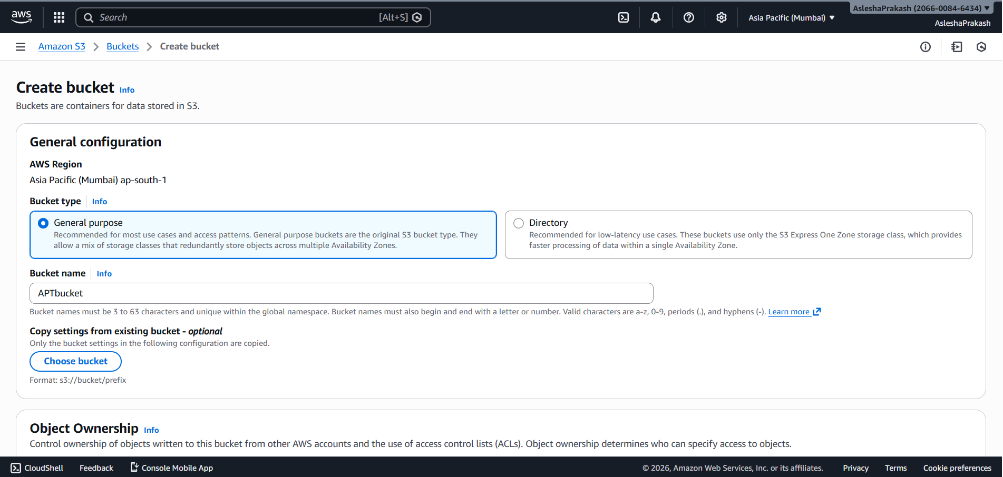

- Under Object Ownership section select ACLs enabled and check Bucket owner preferred as Object ownership.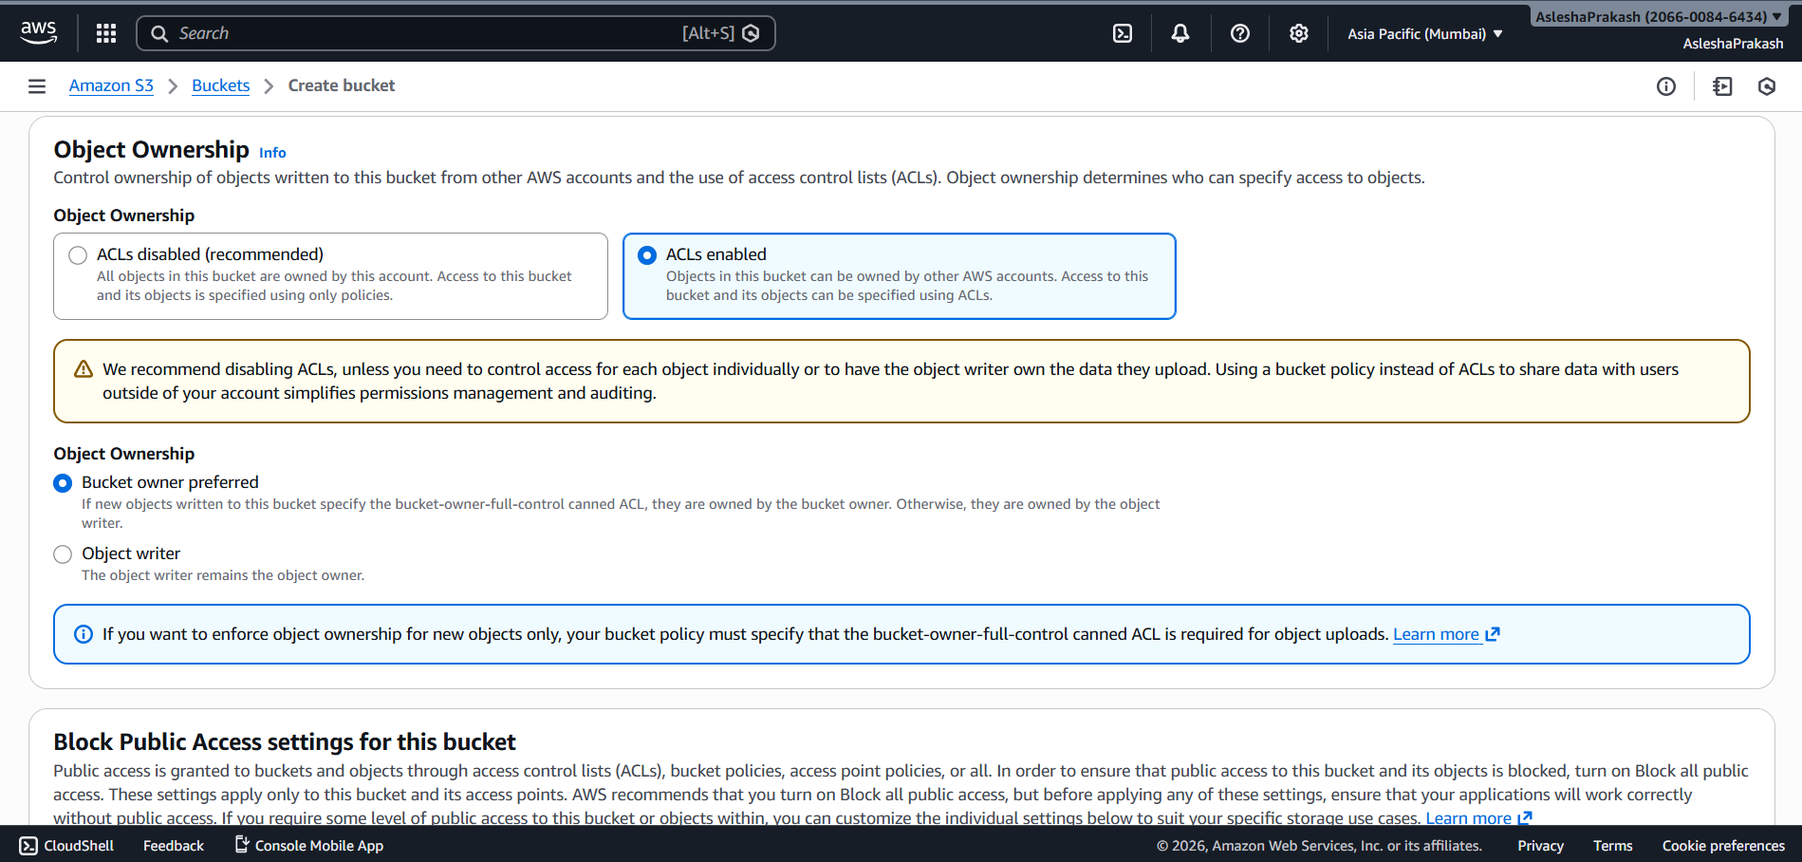

- Make sure the “Block all public access” option is unchecked to create a public bucket. Furthermore check the acknowledgement checkbox beneath.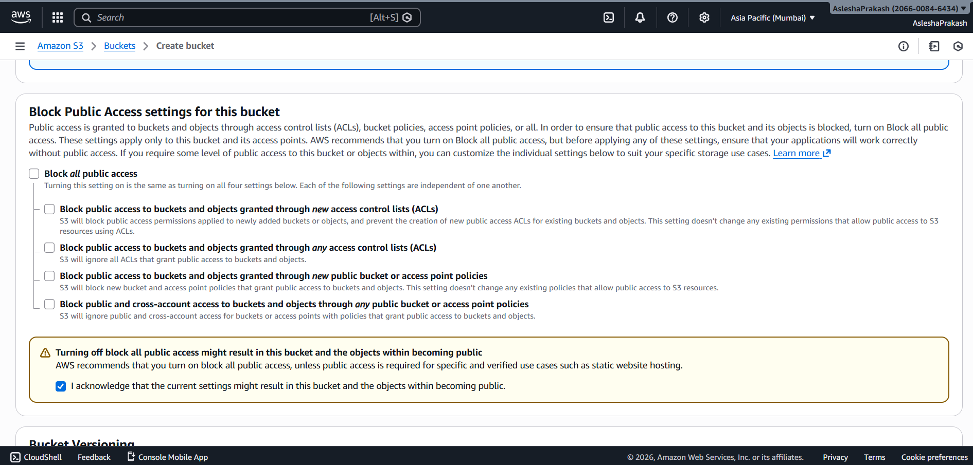

- Under Default encryption section, keep the default selections (SSE-S3 and bucket key enabled) and then click on Create bucket button. 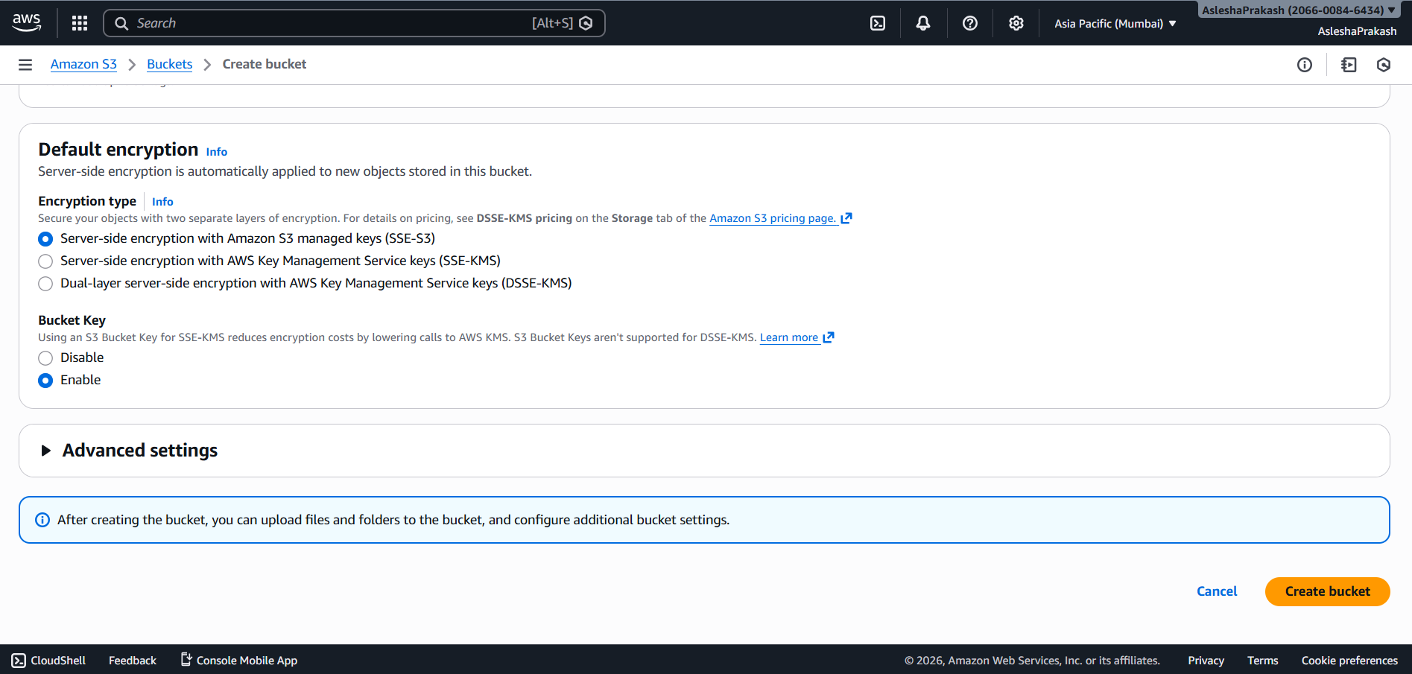

- A green confirmation ribbon will appear on successful creation of the bucket. Furthermore, click on the new bucket just created.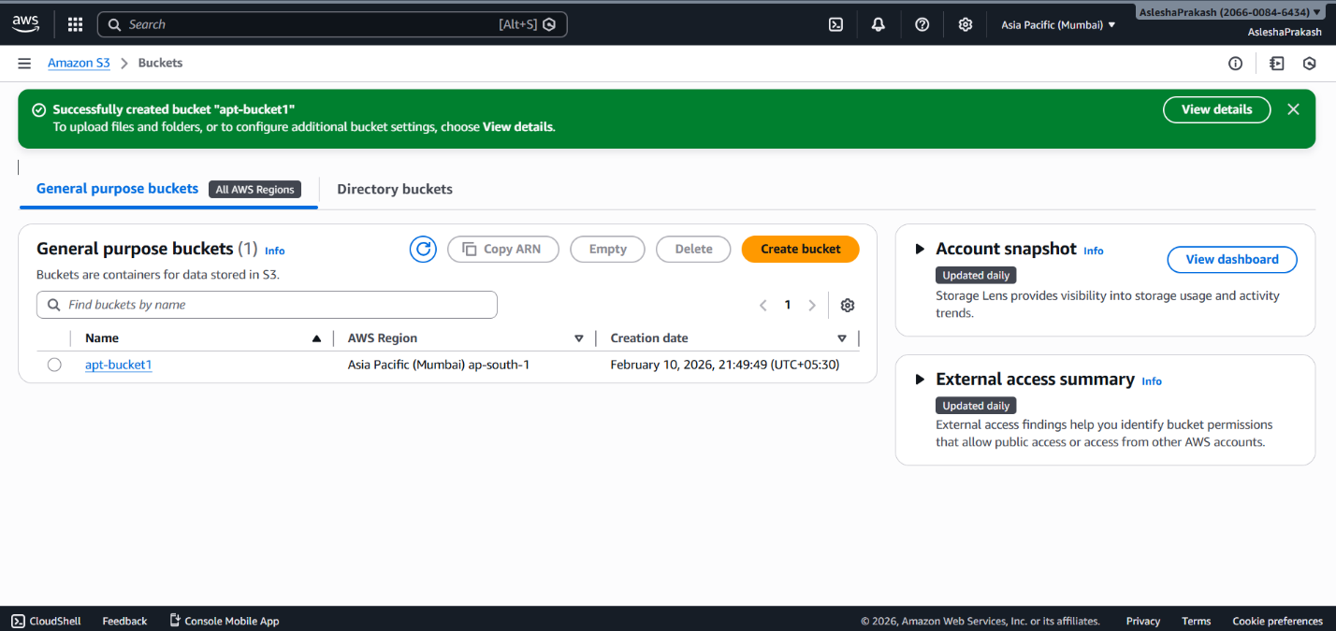

- To upload a media, click on Upload button.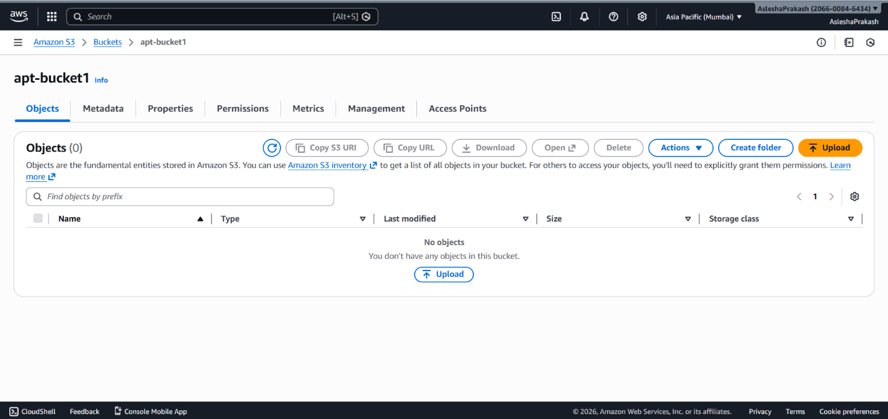

- Click on Add file/folder to upload any kind of files/folders.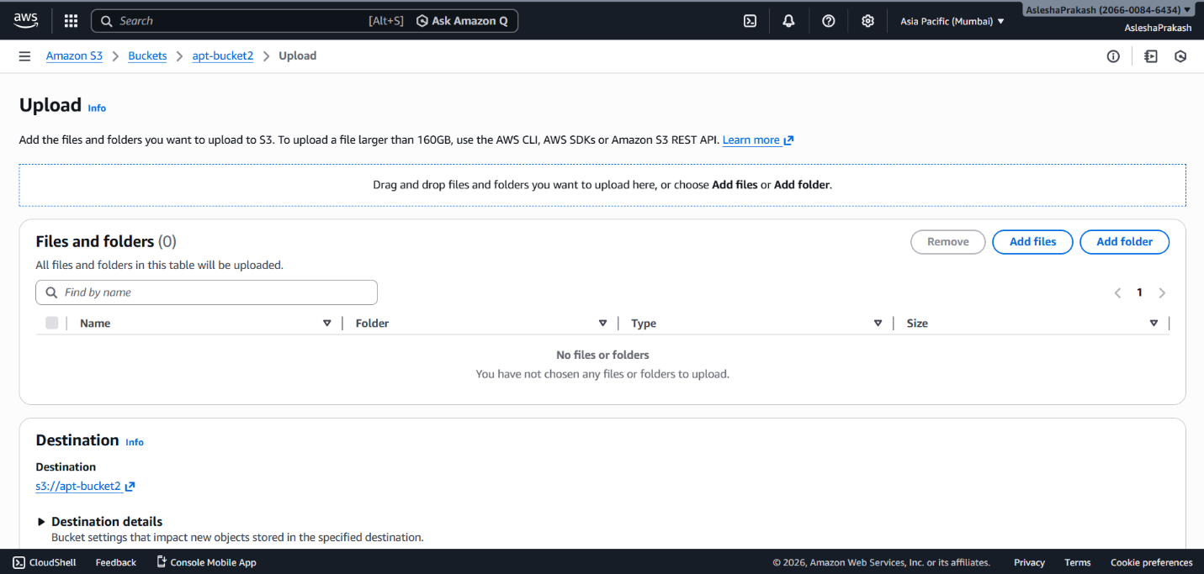

- Once the desired files/folders are uploaded they will be listed. On successfullisting, click on Upload button. 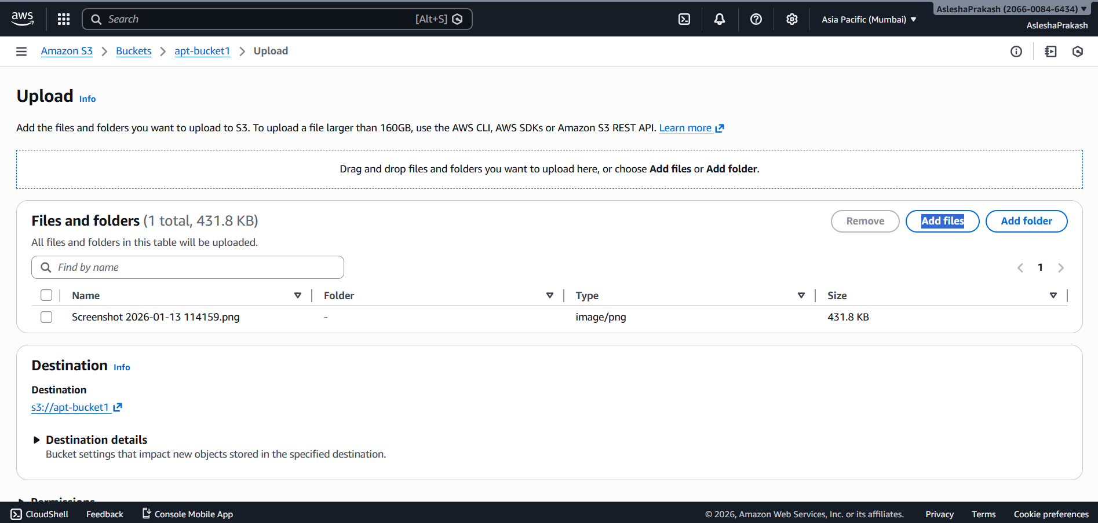

- A green confirmation ribbon will appear marking successful upload. Click on Close to return to the bucket.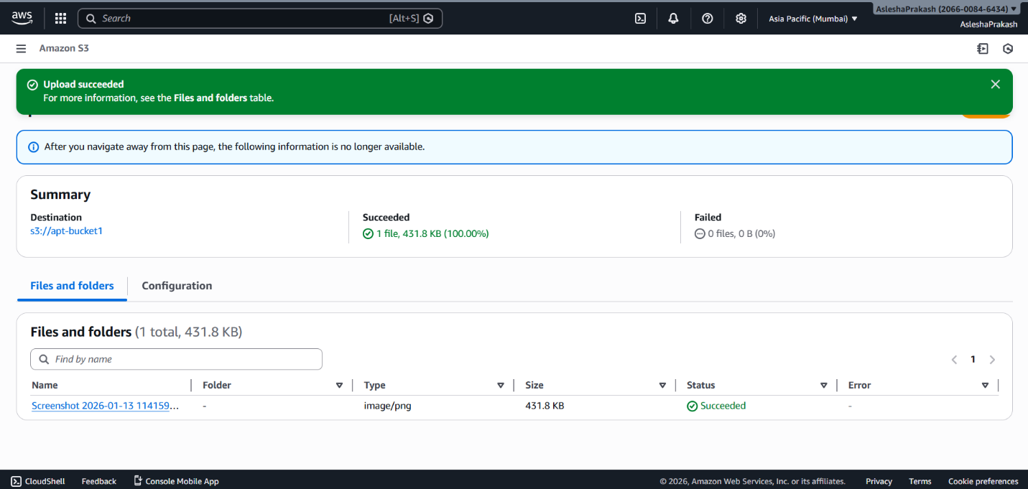

- Click on uploaded file name to view details of it.

- Click on Edit option.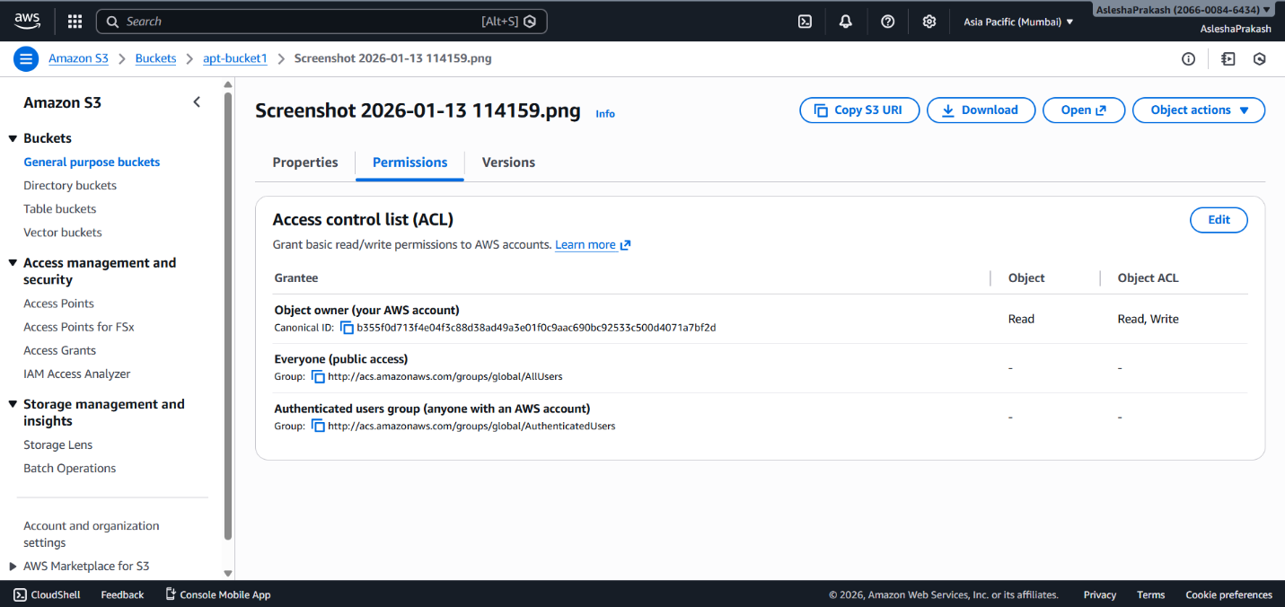

- To give it public access, make sure the Read checkboxes are checked in Every one option and acknowledge the acknowledgement and click on Save changes.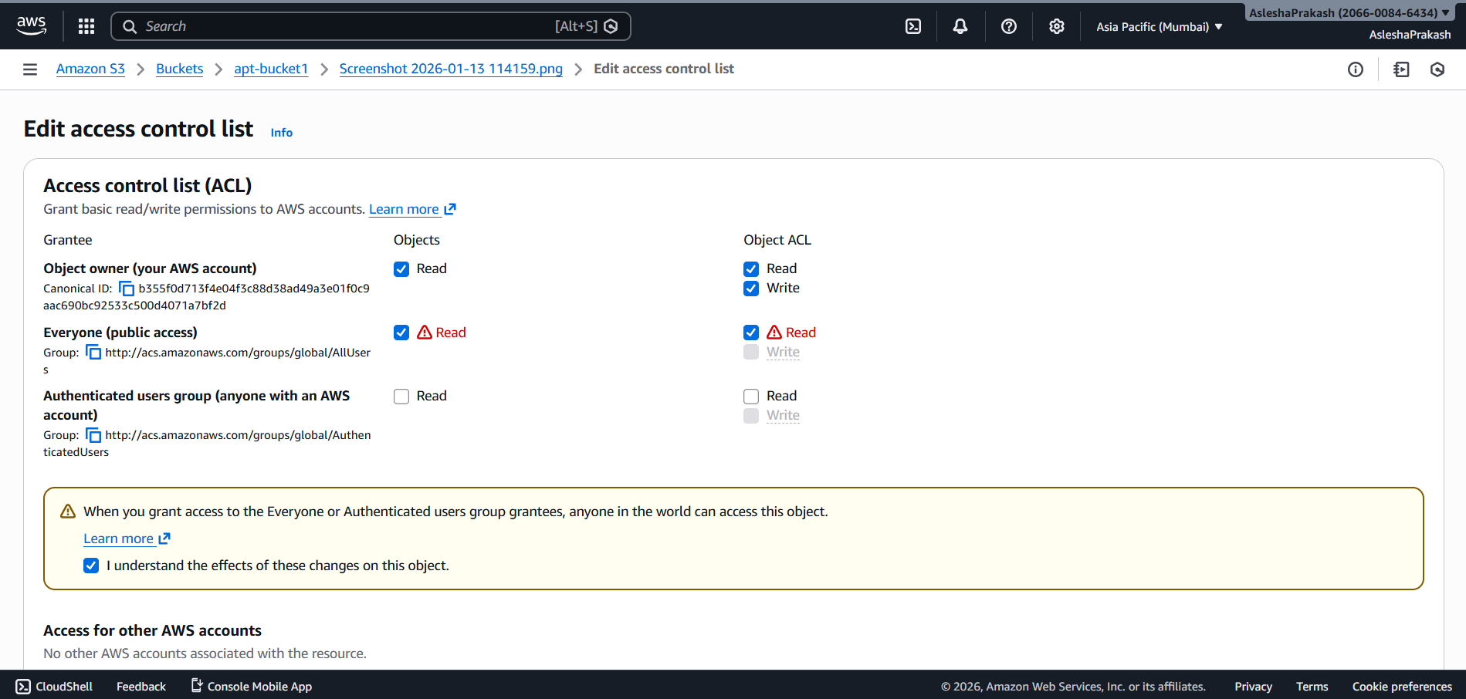

- The file is currently public. Copy the Object URL and open it in another browser or share with a friend to make sure it is publicly visible.